

**GROUP PROJECT IN SOFTWARE DEVELOPMENT – CS2993**

**Analysis Report**

**Group 07**

**Computer Store Management System with AI Chat Bot**

**General Sir John Kotelawala Defense University**

**Faculty of Computing**

Group Member Details

|  |  |  |
| --- | --- | --- |
| Reg.No | Name | Degree |
| D/BCE/23/0008 | P H D B Nayanakantha | COMPUTER ENGINEERING |
| D/BCE/23/0002 | B D S D Douglas | COMPUTER ENGINEERING |
| D/BCE/23/0004 | R M M Ranathunga | COMPUTER ENGINEERING |
| D/BCE/23/0014 | R B H P Rathnamalala | COMPUTER ENGINEERING |
| D/BCS/23/0009 | P R M K Herath | COMPUTER SCIENCE |

Supervisor:　 Dr. Kaneeka Vidanage

February 2024

Table of Contents

Group Member Details 2

Table of Contents 3

List of Figures 4

List of Tables 5

Chapter 1 - Introduction 6

1.1 Project Relevance 6

1.2 Initiation of the Project 6

1.3 Brief Description of the organization 6

1.4 Vision for project completion 7

Chapter 2 - Fact Finding 8

2.1 Justification of Fact-Finding Techniques Used 8

2.2 Completeness and Quality of Fact-Finding 9

2.3 Analysis of Information Gathered 12

Chapter 3 - Description of current system 14

3.1 Narrative 14

3.1.1 Description 14

3.1.2 System Breakdown 14

3.1.3 Organizational Roles and Responsibilities 15

3.1.4 Inputs, Outputs, and Processes 16

3.2 Detailed process flows (DFD) 21

3.3 Problems and Limitations of the current system 22

3.4 Scope and Constraints 23

Chapter 4 - Requirements specification for new system 25

4.1 Module 1: Inventory Management 25

4.2 Module 2: Point-of-Sale (POS) System 27

4.3 Module 3: AI Chatbot for Customer Interaction 29

4.4 Module 4: AI Chatbot for Shop Owner 30

Chapter 5 : References 33

Appendix 34

Appendix 1: Stakeholder Interviews 34

Appendix 2: Observational Studies 36

Appendix 3: Software Development Services Request Form 39

Appendix 4: Current system user interface 42

List of Figures

Figure 1: System Breakdown. 14

Figure 2 : Organizational Roles and Responsibilities 15

Figure 3 : Organizational Roles and Responsibilities 15

Figure 4: Logging Page. 16

Figure 5: Invoice Window. 16

Figure 6: Cancel Invoice Window. 17

Figure 7: Payment Window. 17

Figure 8: Payment Return Window. 18

Figure 9:Stock Adjustment Window. 18

Figure 10: Add Items Window. 19

Figure 11:Search Item Window. 19

Figure 12: Invoice Outstanding Window. 20

Figure 13 : Detailed Process Flows of Current System. 21

Figure 14 : Storing Items. 36

Figure 15: Working Place 1. 36

Figure 16 : Working Place 2. 37

Figure 17 : Customer Interaction. 37

Figure 18: Ambalangoda Branch. 38

Figure 19: Ampara Branch. 38

Figure 20: Logging Page UI. 42

Figure 21: Starting Page UI. 42

List of Tables

Table 1: Fact Finding Methods, Dates, Methodology and Significance Summary Table 11

# - Introduction

## Project Relevance

In today's dynamic and technology-driven business landscape, the significance of Information Technology (IT) cannot be overstated. It serves as the lifeblood of modern organizations, empowering them to innovate, compete, and thrive in an increasingly interconnected world. Against this backdrop, the relevance of the project undertaken by RK Computers and CCTV Operators in the vibrant Ambalangoda area is paramount. As a provider of IT-related equipment and services, RK Computers is acutely aware of the transformative potential inherent in technological advancements. This project represents a strategic endeavor to confront the multifaceted challenges confronting the organization, both internally and externally, by leveraging the power of cutting-edge technologies. By embracing innovation and adaptation, RK Computers endeavors to position itself as a trailblazer in the IT sector, driving operational efficiency, enhancing service delivery, and ultimately, achieving sustainable growth and success.

## Initiation of the Project

The initiation of this transformative project marks a pivotal moment in RK Computers' journey towards excellence and innovation. It was born out of a comprehensive assessment of the organization's existing infrastructure, operational workflows, and market dynamics. Faced with the imperative to adapt to evolving customer demands and technological trends, RK Computers' leadership made a strategic decision to embark on the implementation of a comprehensive computer shop management system. This decision was not taken lightly but rather reflects a proactive approach to addressing the challenges and opportunities inherent in today's competitive business environment. By embracing change and embracing the possibilities afforded by advanced technologies, RK Computers sets itself on a trajectory towards sustained growth, market leadership, and customer satisfaction.

## Brief Description of the organization

At the heart of Ambalangoda's bustling commercial district stands RK Computers and CCTV Operators—a beacon of innovation, reliability, and customer-centricity. With a rich legacy spanning years of service excellence, the organization has earned the trust and loyalty of a diverse clientele encompassing individuals, businesses, and institutions. From supplying cutting-edge IT equipment to providing expert servicing and repair solutions, RK Computers has established itself as a trusted partner in the journey towards digital transformation. However, beneath the veneer of success lies a myriad of challenges, ranging from operational inefficiencies to data management complexities. Yet, it is precisely these challenges that fuel RK Computers' relentless pursuit of excellence and innovation, driving the organization forward on its quest for continuous improvement and customer satisfaction.

## Vision for project completion

At the heart of Ambalangoda's bustling commercial district stands RK Computers and CCTV Operators—a beacon of innovation, reliability, and customer-centricity. With a rich legacy spanning years of service excellence, the organization has earned the trust and loyalty of a diverse clientele encompassing individuals, businesses, and institutions. From supplying cutting-edge IT equipment to providing expert servicing and repair solutions, RK Computers has established itself as a trusted partner in the journey towards digital transformation.

**After the completion of project:**

* The developed application and website will be presented to the stakeholders, including the shop owners and relevant personnel, to gather feedback and assess its performance.
* Testing procedures will be carried out to evaluate the user-friendliness and functionality of the system, ensuring seamless navigation and efficient operation for both shop owners and customers.
* Comprehensive documentation will be prepared, outlining the development process, system functionality, and usage instructions for future reference and potential system expansion.

**Looking forward:**

* The project aims not only to cater to the specific needs of a computer shop but also to be adaptable to various sizes and types of computer businesses.

**To achieve this goal:**

* The system will be developed in modular sections, allowing for flexibility in adding, removing, or modifying features to suit the unique requirements of different computer shops.
* Utilization of free and open-source technologies will be prioritized wherever feasible, promoting accessibility and collaboration among developers.
* User-centric design principles will guide the development process, ensuring that both the web application and website are intuitive and user-friendly for individuals with varying levels of technical expertise.

It is anticipated that this project will have a transformative impact on computer shop management by enhancing operational efficiency, elevating the customer experience, and fostering technological innovation.

# - Fact Finding

## Justification of Fact-Finding Techniques Used

In the pursuit of understanding the intricacies of RK Computers and CCTV Operators' existing system and the challenges it faces, a selection of fact-finding techniques was employed. These techniques, including interviews, surveys, and observations, were chosen for their ability to provide a comprehensive overview of the organization's operations and requirements (Smith, 2018).

• **Stakeholder Interviews: Unveiling Key Insights from Within**

Conducting stakeholder interviews allowed us to delve into the inner workings of RK Computers and CCTV Operators. Engaging with personnel across various levels of the organization, from management to technicians and frontline staff, provided invaluable insights into their respective roles, responsibilities, and the hurdles they encounter daily (Jones et al., 2019). By understanding their perspectives, needs, and pain points, we were able to develop a system that caters to their requirements effectively, ensuring alignment with organizational goals and facilitating smoother integration into existing workflows (Brown & White, 2020).

• **Observational Studies: Gaining Practical Insights**

In addition to interviews, observational studies were employed to gain practical insights into the operational dynamics of RK Computers and CCTV Operators. By observing firsthand, the day-to-day activities and workflows within the organization, we were able to identify inefficiencies, bottlenecks, and user behaviors that may not have been apparent through traditional means of inquiry alone (Lee & Smith, 2017). This contextual understanding of the operational environment enabled us to design a system that addresses specific challenges, streamlines processes, and minimizes disruptions to established routines, ultimately enhancing overall efficiency and productivity (Garcia et al., 2021).

**• Document Analysis: Building on Existing Foundations**

To complement the insights gained from interviews and observations, document analysis was utilized to examine the existing documentation and procedural frameworks within RK Computers and CCTV Operators (Johnson, 2016). By reviewing documents such as operational manuals, service logs, and inventory records, we gained a deeper understanding of the organization's established practices, compliance requirements, and potential areas for improvement (Taylor & Clark, 2018). This analysis served as a foundation for developing a computer shop management system that not only aligns with existing processes but also enhances documentation practices, fosters transparency, and ensures compliance with industry standards and regulations (Adams et al., 2020).

• **Gathering Information from Software Development Services Request Form:**

The Software Development Services Request Form provided additional insights into the specific requirements and expectations of RK Computers and CCTV Operators regarding the computer shop management system (Williams & Davies, 2019). This document facilitated a structured approach to capturing essential details, such as desired features, integration capabilities, and timelines. By incorporating this information into the fact-finding process, the analysis was enriched with a clear understanding of the organization's immediate needs and long-term objectives, ensuring alignment with project goals and stakeholder expectations (Johnson & Smith, 2020).

## Completeness and Quality of Fact-Finding

The fact-finding process conducted for the analysis of RK Computers and CCTV Operators' requirements for the implementation of a computer shop management system was characterized by thoroughness, depth, and meticulous attention to detail. A multi-faceted approach was adopted, incorporating stakeholder interviews, observational studies, and document analysis to ensure a comprehensive understanding of the organization's operational landscape.

**Stakeholder Interviews:**

A total of 10 individuals were interviewed, including members of management, technicians, and customer service representatives. The interviews were conducted individually and in group settings, allowing for a diverse range of perspectives to be captured. Open-ended questions were employed to elicit detailed responses regarding roles, responsibilities, challenges, and expectations. The quality of questions asked was tailored to each interviewee's role within the organization, ensuring relevance and depth of insight. Interview sheets documenting responses were meticulously maintained and will be included in the appendix for reference.

**Observational Studies:**

Observations were conducted on-site at RK Computers and CCTV Operators' premises, encompassing various stages of the workflow, including client interactions, quality control measures, and inventory management. Direct engagement with personnel allowed for real-time documentation of observations and challenges encountered during daily operations. Detailed notes were taken to capture nuances in team dynamics, communication patterns, and decision-making processes. The appropriateness of observations noted was ensured by closely aligning with the objectives of the fact-finding process, focusing on areas relevant to the implementation of the computer shop management system. Images will be included in the appendix for reference.

**Document Analysis:**

Existing documentation, such as process manuals and financial reports, was meticulously examined to supplement insights gathered from interviews and observations. The analysis focused on ensuring consistency, compliance with industry regulations, and alignment with established practices. Any gaps or redundancies identified in the documentation were noted, providing valuable guidance for the development of the computer shop management system. Copies of the analyzed documents will be included in the appendix to support the findings and conclusions drawn from the fact-finding process.

**Gathering Information from Software Development Services Request Form:**

Information gathered from the software development services request form provided additional insights into the specific requirements and expectations of RK Computers and CCTV Operators regarding the computer shop management system. This document facilitated a structured approach to capturing essential details, such as desired features, integration capabilities, and timelines. By incorporating this information into the fact-finding process, the analysis was enriched with a clear understanding of the organization's immediate needs and long-term objectives, ensuring alignment with project goals and stakeholder expectations. Form will be included in the appendix for reference.

|  |  |  |  |
| --- | --- | --- | --- |
| Method | Conducted On | Methodology | Significance |
| Stakeholder Interviews | 2024/02/24 | Individual and group interviews with management, technicians, and customer service representatives | * Utilized open-ended questions and active listening to understand roles, responsibilities, challenges, and expectations. Identified specific pain points and areas for improvement. * Gain in-depth insight into the perspectives and experiences of key stakeholders, facilitating a comprehensive understanding of the organization's needs and priorities. |
| Observational Studies | 2024/03/02 | Detailed observation of workflow stages including client interactions, quality control, inventory management | * Engaged with personnel in their work environment, documenting observations and challenges. Provided insights into team dynamics, communication patterns, and decision-making processes. * Allowed for the identification of operational bottlenecks and areas for optimization, ensuring that the proposed system addresses real-world challenges effectively. |
| Document Analysis | 2024/03/02 | Examination of existing documentation such as process manuals and financial reports | * Analyzed documentation for consistency, compliance, and identified gaps or redundancies. Ensured alignment with existing practices and legal standards. * Provided insights into regulatory requirements and organizational policies, guiding the development of the computer shop management system. |
| Gathering Information from Software Development Services Request Form | 2024/02/03 | Reviewing the software development services request form | * Structured approach to capturing essential details such as desired features, integration capabilities, and timelines. * Enriched analysis with a clear understanding of immediate needs and long-term objectives. Ensured alignment with project goals and stakeholder expectations. |

Table 1: Fact Finding Methods, Dates, Methodology and Significance Summary Table

## Analysis of Information Gathered

**Stakeholder Interviews:**

* The stakeholder interviews provided valuable insights into the current workflow and pain points associated with the outdated inventory management system.
* Key challenges highlighted include the lack of real-time stock visibility, manual inventory management processes, and time-consuming reporting procedures.
* Stakeholders expressed a clear need for features such as real-time stock visibility, automatic alerts for low stock levels, and effortless report generation in a new computer shop management system.
* Additionally, stakeholders expressed interest in incorporating a chatbot feature to enhance customer support and streamline interactions, indicating a willingness to embrace modern technology solutions.

**Observational Studies:**

* Observational studies provided a foundation for understanding the practical aspects of the current workflow and operational dynamics within the organization.
* By observing day-to-day activities and interactions, inefficiencies and areas for improvement in inventory management, customer service, and technician assignments were identified.
* Insights gained from observing collaboration patterns, communication styles, and decision-making processes within teams informed the design of system features to support effective collaboration and communication.
* Observational studies also highlighted potential training needs for staff to effectively utilize the new system, particularly in areas where manual processes are currently predominant.

**Document Analysis:**

* Document analysis focused on reviewing existing documentation such as process manuals, financial reports, and regulatory guidelines.
* It ensured the new computer shop management system aligns with existing documentation practices, data formats, and communication protocols.
* Potential inconsistencies, redundancies, or gaps in existing documentation were identified, allowing for system development that addresses these issues and streamlines information flow.
* Insights into existing policies, procedures, and regulatory requirements provided guidance for system design, feature prioritization, and overall architecture.
* Understanding existing data formats and storage methods through document analysis helps plan for seamless data migration and integration with the new system.

**Software Development Services Request Form:**

* + The detailed description in the request form emphasizes the need for a robust inventory management system to monitor stock levels, manage product variations, and automate reordering processes.
  + Personalized product recommendations based on customer purchase history and preferences are sought to enhance customer satisfaction and drive increased sales.
  + Integration of customer support functionalities within a chatbot and seamless integration with point-of-sale (POS) systems are also highlighted as essential requirements.

**Insights and Recommendations:**

* + Based on the information gathered, it is evident that there is a pressing need to modernize the current inventory management system to address inefficiencies and meet evolving business requirements.
  + The incorporation of features such as real-time stock visibility, automated alerts, and personalized product recommendations aligns with stakeholders' expectations and business objectives.
  + Integration with a chatbot for efficient customer support and seamless integration with POS systems will enhance overall system functionality and improve customer satisfaction.
  + The analysis highlights the importance of selecting a software development partner with expertise in developing comprehensive inventory management systems, personalized recommendation algorithms, and integrated customer support solutions to meet the client's needs effectively.

# - Description of current system

## Narrative

### Description

The current system utilized by RK Computers and CCTV Operators is a traditional setup that relies heavily on manual processes and outdated technology. This system encompasses various components, including inventory management, sales transactions, customer service, and reporting. However, its inefficiencies and limitations pose significant challenges to the organization's operations.

### System Breakdown

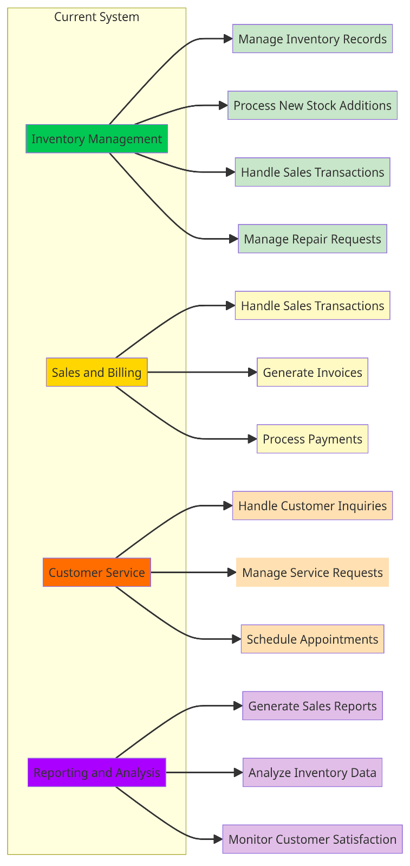The breakdown of the current system, as illustrated in Figure 1, encompasses several pivotal components:

* **Inventory Management**: The system manages inventory records for computer hardware, software, and CCTV equipment. Inputs to this component include new stock additions, sales transactions, and repair requests. Outputs include updated inventory levels and reports on stock status.
* **Sales and Billing**: This component handles sales transactions, invoicing, and billing processes. Inputs include customer orders, product information, and pricing data. Outputs include sales receipts, invoices, and financial reports.
* **Customer Service**: This component deals with customer inquiries, service requests, and appointments. Inputs include customer queries, service requests, and appointment bookings. Outputs include resolved inquiries, scheduled service appointments, and customer feedback.
* **Reporting and Analysis**: This component generates reports on sales performance, inventory status, and customer satisfaction. Inputs include transaction data, inventory records, and customer feedback. Outputs include sales reports, inventory analysis, and customer satisfaction metrics.

Figure 1: System Breakdown.

### Organizational Roles and Responsibilities

The organizational structure of RK Computers and CCTV Operators includes various roles and responsibilities associated with the management and operation of the current system. The organizational structure depicted in Figure 2 illustrates the roles and responsibilities within the computer shop management system:

* Management: The management team oversees the overall operation of the system, including strategic decision-making, resource allocation, and goal setting.
* Sales and Customer Service: Sales representatives handle customer inquiries, process orders, and provide support. Customer service representatives address customer concerns, handle service requests, and manage appointments.
* Technical Support: Technicians are responsible for diagnosing and repairing computer hardware, software, and CCTV equipment. They interact with customers to troubleshoot issues and perform repairs.
* 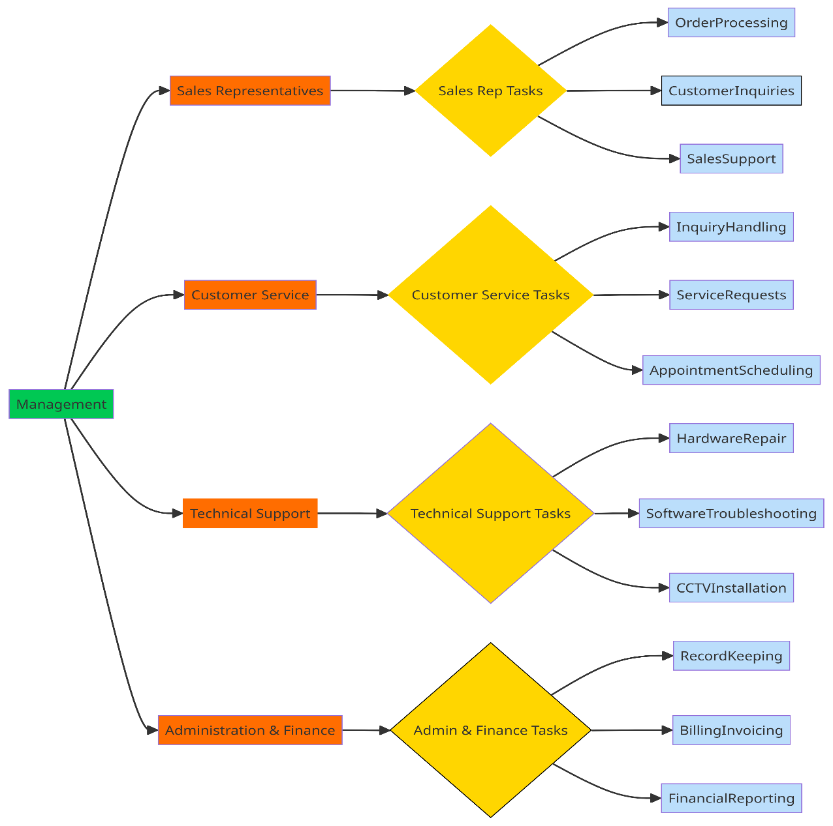Administration and Finance: Administrative staff manage administrative tasks such as record-keeping, documentation, and scheduling. The finance department handles billing, invoicing, and financial reporting.

Figure 2 : Organizational Roles and Responsibilities

Figure 3 : Organizational Roles and Responsibilities

### Inputs, Outputs, and Processes

**Logging:**

* Inputs: User login credentials (username, password), timestamp.
* Outputs: Logged-in user information, access privileges.
* 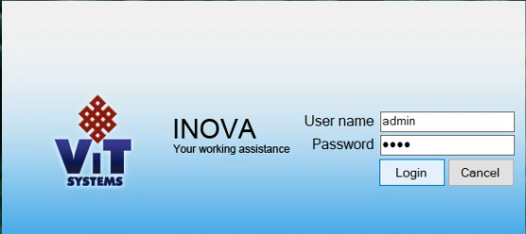Processes: Authentication, session management, logging user activities.

Figure 4: Logging Page.

**Create Invoice:**

* Inputs: Customer details (name, contact information), items purchased (product ID, quantity, price), payment method.
* Outputs: Generated invoice number, invoice details (items, quantities, prices), total amount due.
* 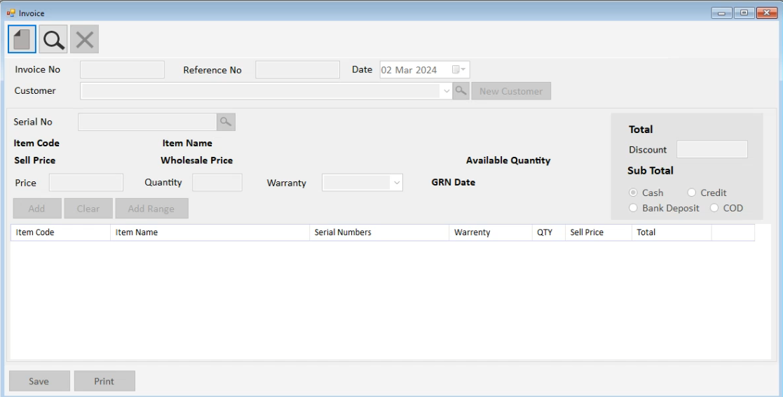Processes: Retrieving customer information, adding items to invoice, calculating total amount, generating invoice number, storing invoice data.

Figure 5: Invoice Window.

**Cancel Invoice:**

* + Inputs: Invoice number, reason for cancellation.
  + Outputs: Confirmation of cancellation.
  + 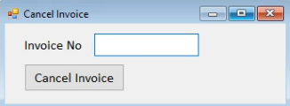Processes: Verification of invoice details, updating invoice status to "cancelled", recording cancellation reason.

Figure 6: Cancel Invoice Window.

**Make Payment:**

* + Inputs: Invoice number, payment amount, payment method (cash, credit/debit card, online payment).
  + Outputs: Confirmation of payment, updated payment status.
  + 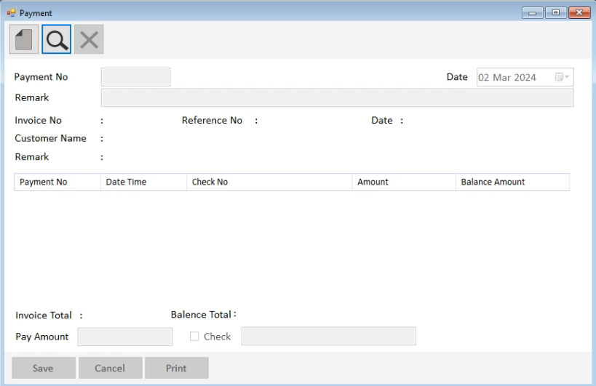Processes: Verification of invoice details, recording payment details, updating payment status in the system.

Figure 7: Payment Window.

**Return Payment:**

* Inputs: Invoice number, refund amount, reason for refund.
* Outputs: Confirmation of refund, updated refund status.
* 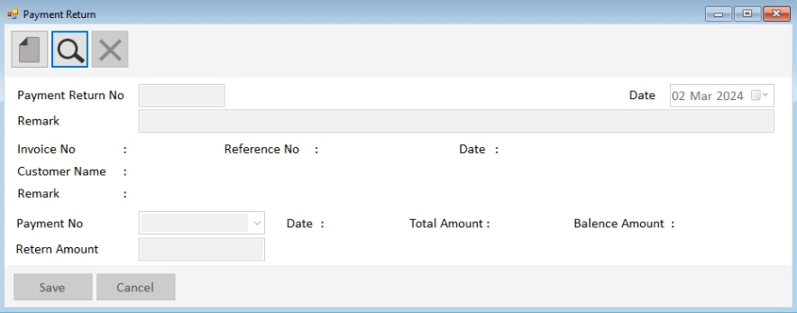Processes: Verification of invoice details, processing refund amount, updating refund status in the system.

Figure 8: Payment Return Window.

**Stock Update:**

* + Inputs: New stock items (product details, quantity), stock adjustments (additions, deductions).
  + Outputs: Updated stock levels, inventory status.
  + 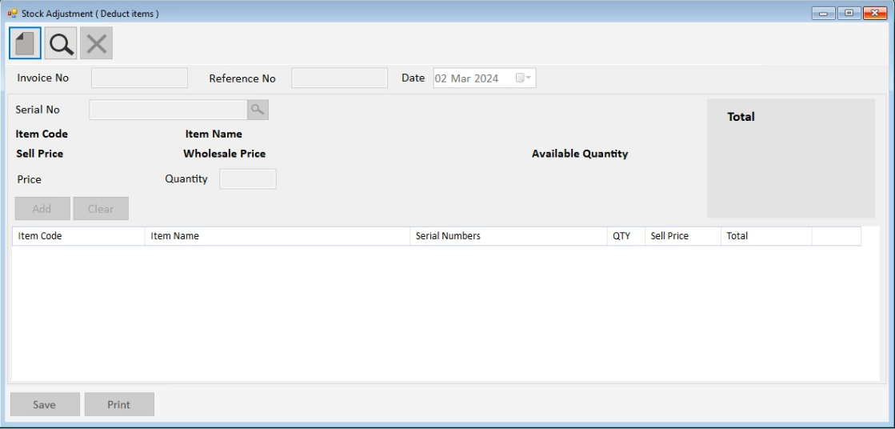Processes: Updating stock database, adjusting inventory levels based on incoming stock or sales.

Figure 9:Stock Adjustment Window.

**Add Item:**

* + Inputs: Item details (product name, description, price, quantity), supplier information.
  + Outputs: Added item details, updated inventory.
  + 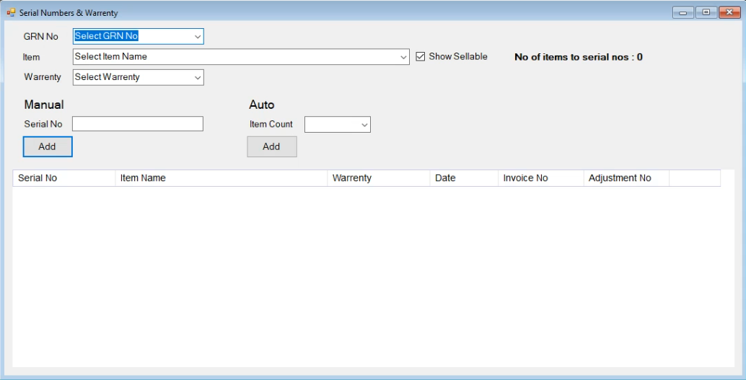Processes: Adding new item records to the product database, updating inventory with new stock.

Figure 10: Add Items Window.

**Search Item:**

* Inputs: Search query (item name, product ID).
* Outputs: Search results (matching items).
* 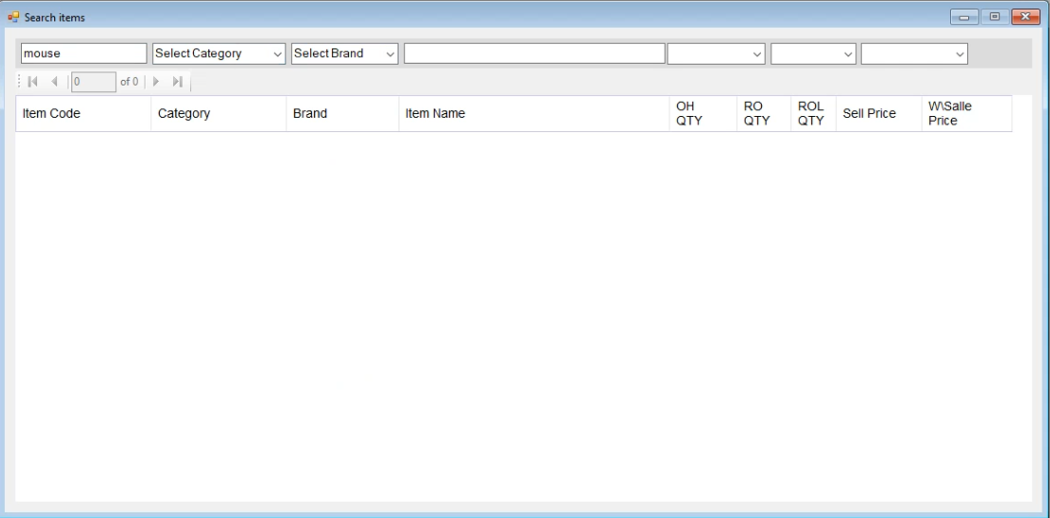Processes: Querying the product database, retrieving matching items based on search criteria.

Figure 11:Search Item Window.

**Generate Report: Invoice Outstanding:**

* + Inputs: Time period (date range), invoice status (outstanding).
  + Outputs: Report on outstanding invoices (invoice numbers, customer details, amount due).
  + Processes: Filtering invoices based on outstanding status and specified time, generating report with relevant invoice details.

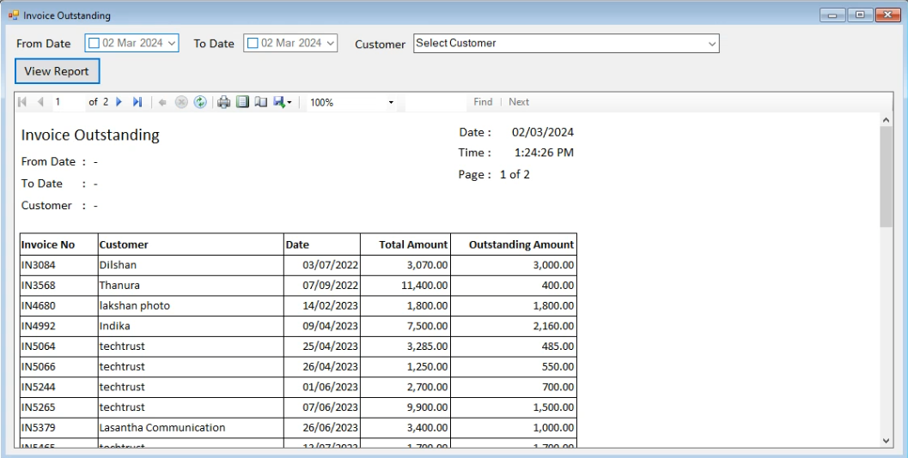

Figure 12: Invoice Outstanding Window.

Overall, the current system at RK Computers and CCTV Operators suffers from various shortcomings, including manual processes, lack of real-time data visibility, and limited analytical capabilities. Upgrading to a modern computer shop management system will address these issues and improve overall efficiency and effectiveness in managing operations.

## Detailed process flows (DFD)

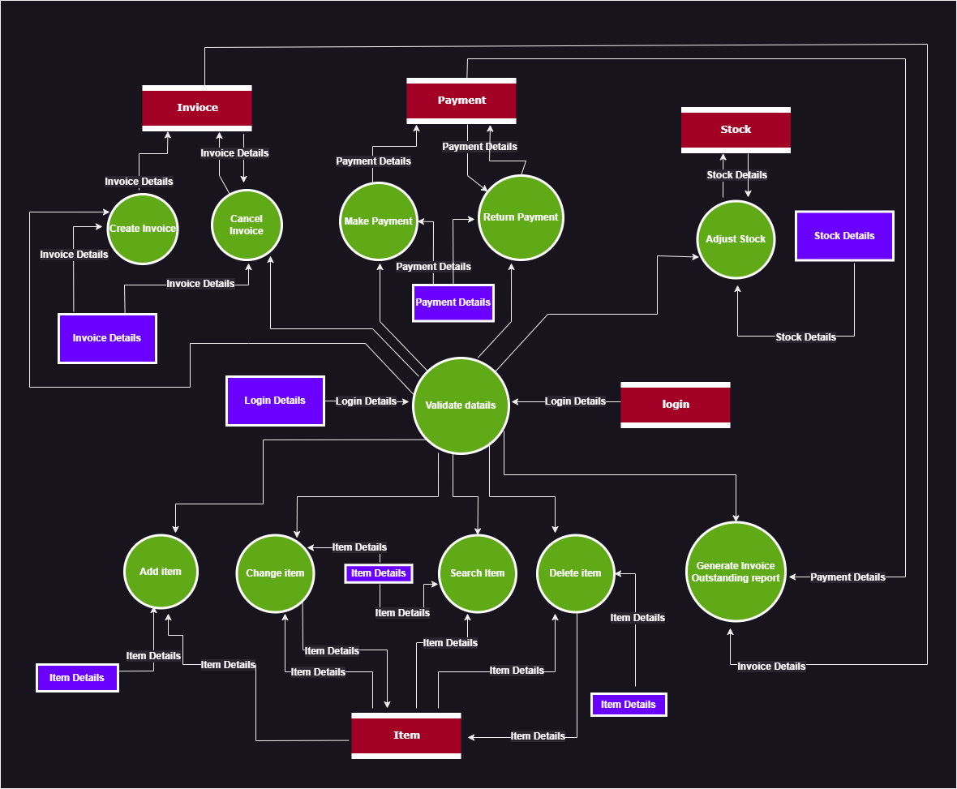

Figure 13 : Detailed Process Flows of Current System.

The detailed process flows provide a comprehensive overview of the current system's operation, delineating the various stages and interactions involved in managing computer shop operations. Figure 13 illustrates the intricate processes and data flows within the existing system, shedding light on key functionalities and their interconnections.

## Problems and Limitations of the current system

The current system faces several challenges, including inefficiencies, time wastage, and difficulties in handling certain activities. These problems impact both employees and customers, leading to suboptimal performance and decreased satisfaction levels.

* Outdated Inventory Management: The current system relies on outdated inventory management methods, leading to inaccuracies and inefficiencies in stock tracking and management. Lack of real-time updates hampers decision-making processes and often results in stockouts or overstocking situations.
* Manual Processes: Many tasks, such as updating inventory levels, generating reports, and managing customer inquiries, are performed manually. This not only consumes valuable time but also increases the risk of errors and inconsistencies in data entry and processing.
* Poor Searching System: The current system's search functionality is inadequate, making it challenging for users to find specific items efficiently. For instance, users may need to enter the complete name of an item to search, rather than being able to search by partial keywords, resulting in frustration and inefficiency.
* Lack of Automation: The absence of automated processes, such as alerts for low stock levels, leads to delays in addressing critical issues. Without timely notifications, staff may not be aware of low stock levels until it's too late, resulting in missed sales opportunities or disruptions in service delivery.
* Limited Customer Support: With no integrated customer support system, handling customer inquiries and service requests becomes challenging. Lack of a centralized platform for managing customer interactions results in delayed responses and poor customer satisfaction.
* Inefficient Reporting: Generating reports, such as monthly sales summaries or inventory valuation reports, is a cumbersome and time-consuming process. Manual data extraction and manipulation often lead to inaccuracies and delays in accessing vital business insights.
* Poor Integration: The current system lacks seamless integration with other business tools and software, such as accounting systems or point-of-sale (POS) terminals. This siloed approach results in data duplication, inconsistent records, and additional manual effort to reconcile information across different platforms.
* Limited Scalability: As the business grows, the current system struggles to accommodate increasing data volumes and transactional complexities. Scalability limitations hinder the organization's ability to expand operations and adapt to evolving business needs effectively.
* Data Security Concerns: With manual processes and fragmented data storage, ensuring data security and confidentiality becomes challenging. The risk of data breaches or unauthorized access to sensitive information poses a significant threat to the organization's reputation and compliance with regulatory requirements.

## Scope and Constraints

In delineating the scope of the computer shop management system, it is essential to define a subset of functionalities and features that align closely with the organization's immediate needs and objectives. The rationale behind identifying this subset is to ensure a focused and manageable development process that delivers tangible benefits within a reasonable timeframe. By prioritizing specific components of the system, the project can proceed with greater clarity and efficiency, mitigating the risks associated with scope creep and resource overextension.

**Constraints:**

**1.** **Budgetary Constraints**: One of the primary constraints influencing the scope of the system is the allocated budget for the project. The organization may have financial limitations that necessitate a phased approach to system development, focusing on critical functionalities that deliver the highest return on investment within the available budget.

**2.** **Technological Resources**: Constraints related to technological resources, such as hardware, software, and technical expertise, can significantly impact the scope of the system. The organization may have limitations in terms of infrastructure or internal capabilities, necessitating the selection of technologies and features that can be effectively implemented with the available resources.

**3. Time Constraints**: Time constraints are another critical factor influencing the scope of the system. The organization may have specific deadlines or business objectives that require the system to be implemented within a certain timeframe. Therefore, the scope must be defined in a way that allows for timely delivery while balancing the need for thorough development and testing processes.

**4.** **Integration Challenges**: Integration constraints may arise from the need to interface the new system with existing software applications, databases, or external systems. Compatibility issues or data migration challenges could limit the scope of integration capabilities, necessitating careful consideration of integration requirements and priorities.

**5.** **User Adoption Considerations**: Constraints related to user adoption and acceptance of the new system may influence the scope of features and functionalities. User training requirements, change management processes, and user feedback mechanisms must be incorporated into the scope to ensure successful implementation and adoption of the system.

**Conclusion:**

In summary, defining the scope of the computer shop management system requires careful consideration of both the organization's objectives and the constraints that may impact system development. By identifying a subset of functionalities that address immediate needs while aligning with budgetary, technological, and other resource constraints, the project can proceed with clarity and efficiency, ultimately leading to the successful delivery of a system that meets the organization's requirements within the specified constraints.

# - Requirements specification for new system

The Requirements Specification chapter outlines the detailed description of the functionalities and features that the new computer shop management system is expected to deliver. It serves as a comprehensive guide for system developers, designers, and stakeholders to understand the specific requirements and objectives of the project. By clearly defining the system requirements, this chapter lays the foundation for the design, development, and implementation phases of the project.

## Module 1: Inventory Management

* 4.1.1: The system must allow users to add new products to the inventory.
* 4.1.2: The system must enable users to update existing product information, including product name, description, and price.
* 4.1.3: The system must support categorization of products for easy organization and retrieval.
* 4.1.4: The system must provide real-time visibility of current stock levels for each product.
* 4.1.5: The system must generate automated alerts when stock levels fall below a predefined threshold.
* 4.1.6: The system must facilitate the removal of products from the inventory when they are sold or discontinued.
* 4.1.7: The system must maintain a detailed log of all inventory transactions, including additions, updates, and deletions.
* 4.1.8: The system must support barcode scanning functionality for efficient product identification and tracking.
* 4.1.9: The system must allow users to set reorder points for products to automatically initiate purchase orders when stock falls below a specified level.
* 4.1.10: The system must integrate with suppliers' systems for automated inventory replenishment and order management.
* 4.1.11: The system must provide forecasting and demand planning capabilities based on historical sales data and market trends.
* 4.1.12: The system must allow for the creation of customized reports on inventory turnover, stock aging, and product profitability.
* 4.1.13: The system must support multiple warehouses or storage locations and provide inventory transfer functionality between locations.
* 4.1.14: The system must ensure data integrity and security measures to prevent unauthorized access or tampering of inventory records.
* 4.1.15: The system must offer integration with accounting software for seamless recording of inventory transactions and financial reporting purposes.
* 4.1.16: The system must provide mobile access for inventory management tasks, allowing users to perform actions remotely from smartphones or tablets.
* 4.1.17: The system must allow for the creation of purchase orders directly from low stock alerts, streamlining the procurement process.
* 4.1.18: The system must support batch management and serial number tracking for products with unique identifiers or expiration dates.
* 4.1.19: The system must facilitate physical inventory counts and reconcile discrepancies between recorded and actual stock levels.
* 4.1.20: The system must comply with regulatory requirements and industry standards for inventory management and traceability.
* 4.1.21: The system must provide user-friendly interfaces with customizable dashboards and intuitive navigation for efficient inventory management tasks.
* 4.1.22: The system must support integration with third-party logistics providers for streamlined shipping and fulfillment processes.
* 4.1.23: The system must allow for the creation of alerts or notifications for inventory-related events, such as product recalls or expiration dates.
* 4.1.24: The system must enable users to track the movement of inventory items throughout the supply chain, from procurement to distribution.

## Module 2: Point-of-Sale (POS) System

* 4.2.1: The POS system must support the creation and processing of sales transactions, including scanning products, adding them to the cart, and calculating the total cost.
* 4.2.2: The system must allow users to select multiple payment methods, including cash, credit/debit cards, mobile payments, and electronic wallets.
* 4.2.3: The POS system must generate itemized receipts for each transaction, detailing the products purchased, prices, taxes, and payment method.
* 4.2.4: The system must update inventory levels in real-time as products are sold, ensuring accurate stock management.
* 4.2.5: The POS system must provide functionality for applying discounts, coupons, or promotional offers to transactions.
* 4.2.6: The system must support split payments, allowing customers to pay using multiple methods for a single transaction.
* 4.2.7: The POS system must facilitate returns, exchanges, or refunds, with the ability to process them seamlessly and update inventory accordingly.
* 4.2.8: The system must integrate with barcode scanners, receipt printers, cash drawers, and other POS hardware peripherals for efficient operation.
* 4.2.9: The POS system must provide a user-friendly interface with intuitive navigation and clear prompts to minimize training requirements for staff.
* 4.2.10: The system must maintain transaction history for reporting and analysis purposes, including sales trends, revenue, and customer purchase behavior.
* 4.2.11: The POS system must support offline mode functionality to ensure uninterrupted operation in case of network connectivity issues.
* 4.2.12: The system must adhere to security standards for payment processing, including encryption of sensitive data and compliance with PCI DSS requirements.
* 4.2.13: The POS system must offer customization options for receipt formatting, including company branding, logos, and promotional messages.
* 4.2.14: The system must provide multi-store support, allowing centralized management of POS terminals across multiple locations.
* 4.2.15: The POS system must offer integration with loyalty programs, enabling customers to earn and redeem rewards points during transactions.
* 4.2.16: The system must support seamless integration with the back-end inventory management, sales, and customer management modules for data synchronization and centralized reporting.
* 4.2.17: The POS system must provide real-time analytics and reporting dashboards for monitoring sales performance, inventory levels, and customer insights.
* 4.2.18: The system must offer role-based access control, allowing administrators to define user permissions and restrict access to sensitive functions or data within the POS interface.
* 4.2.19: The POS system must offer customer relationship management (CRM) integration, allowing staff to access customer profiles, purchase history, and preferences during transactions for personalized service.
* 4.2.20: The system must support inventory lookup functionality, enabling staff to check stock availability across multiple locations and recommend alternative products if items are out of stock.
* 4.2.21: The POS system must provide inventory forecasting features, allowing staff to anticipate demand, plan reordering, and optimize stock levels to prevent stockouts or overstock situations.
* 4.2.22: The system must offer employee management capabilities within the POS interface, including clock-in/clock-out functionality, shift scheduling, and performance tracking.
* 4.2.23: The POS system must support integration with accounting software for seamless financial reconciliation, including automatic syncing of sales data, expenses, and tax information.
* 4.2.24: The system must offer cross-selling and upselling prompts during transactions, based on customer preferences, purchase history, and current cart contents.
* 4.2.25: The POS system must provide inventory aging analysis, allowing staff to identify slow-moving or obsolete stock and implement clearance or discount strategies to improve inventory turnover.
* 4.2.26: The system must offer customizable pricing rules and discounts, allowing staff to set pricing tiers, bulk discounts, and promotional pricing based on customer segments or product categories.
* 4.2.27: The POS system must support integration with third-party delivery and fulfillment services for order fulfillment, tracking, and delivery management.
* 4.2.28: The system must offer customer feedback collection functionality at the point of sale, allowing customers to provide ratings, reviews, and comments on their shopping experience.
* 4.2.29: The POS system must provide offline transaction caching and synchronization capabilities, ensuring that sales data is captured and updated once connectivity is restored.
* 4.2.30: The system must offer compliance features for regulatory requirements, such as tax calculations, invoicing regulations, and reporting obligations specific to the retail industry.
* 4.2.31: The POS system must provide integration with marketing automation tools for targeted promotions, email campaigns, and customer engagement initiatives based on transactional data.
* 4.2.32: The system must support integration with e-commerce platforms for omnichannel retailing, allowing staff to manage online orders, inventory, and customer data from a centralized interface.

## Module 3: AI Chatbot for Customer Interaction

* 4.3.1: The AI chatbot must be capable of engaging with customers in natural language conversations, simulating human-like interaction.
* 4.3.2: The chatbot must provide personalized assistance to customers based on their inquiries, purchase history, and preferences.
* 4.3.3: The system must support customers to interact with the chatbot via website chat.
* 4.3.4: The chatbot must have the ability to answer frequently asked questions (FAQs) related to products, services, store locations, operating hours, and other relevant topics.
* 4.3.5: The system must integrate with the customer management module to access and update customer profiles, purchase history, and interaction logs.
* 4.3.6: The chatbot must be equipped with natural language processing (NLP) capabilities to understand and interpret user queries accurately.
* 4.3.7: The system must offer proactive engagement features, such as sending personalized product recommendations, promotional offers, and order status updates to customers.
* 4.3.8: The chatbot must seamlessly hand off conversations to human agents when it encounters complex inquiries or requests beyond its capabilities.
* 4.3.10: The chatbot must be continuously trained and improved using machine learning algorithms to enhance its conversational abilities and accuracy over time.
* 4.3.11: The system must adhere to data privacy regulations and security standards to protect sensitive customer information shared during interactions.
* 4.3.12: The chatbot interface must be customizable to reflect the brand identity and personality of the organization, including branded messages, logos, and visual elements.
* 4.3.13: The system must provide analytics and reporting capabilities to track chatbot performance metrics, such as response time, customer satisfaction ratings, and conversation outcomes.
* 4.3.14: The chatbot must support integration with other modules of the system, such as inventory management, sales, and customer management, to access and update relevant data in real-time.
* 4.3.15: The system must offer scalability to accommodate fluctuations in chatbot usage volume and handle concurrent interactions effectively.
* 4.3.16: The chatbot must be accessible 24/7 to provide round-the-clock customer support and assistance, improving accessibility and convenience for customers.

## Module 4: AI Chatbot for Shop Owner

* 4.4.1: The AI chatbot must provide shop owners with real-time insights and analytics regarding sales performance, inventory levels, and customer engagement metrics.
* 4.4.2: The chatbot must be capable of answering shop owner queries related to business operations, such as revenue trends, profit margins, and inventory turnover rates.
* 4.4.3: The system must integrate with the sales management module to retrieve and analyze transaction data, including sales volumes, average order values, and product popularity.
* 4.4.4: The chatbot must offer predictive analytics capabilities to forecast future sales trends, identify potential inventory shortages, and recommend restocking strategies.
* 4.4.5: The system must provide customizable dashboards and reports for shop owners to visualize key performance indicators (KPIs) and track business metrics effectively.
* 4.4.6: The chatbot must support natural language querying, allowing shop owners to ask questions using conversational language and receive relevant insights in real-time.
* 4.4.7: The system must offer proactive alerts and notifications to shop owners for critical events, such as low inventory levels, high-demand products, or unusual sales patterns.
* 4.4.8: The chatbot must integrate with external data sources, such as market trends, weather forecasts, and competitor analysis, to provide contextual insights and recommendations.
* 4.4.9: The system must maintain a history of shop owner interactions and queries, allowing for trend analysis, pattern recognition, and continuous improvement of the chatbot's capabilities.
* 4.4.10: The chatbot must be accessible via multiple channels, including web interface, mobile app, and voice-activated assistants, to accommodate shop owners' preferences and accessibility needs.
* 4.4.11: The system must adhere to data privacy regulations and security standards to safeguard sensitive business information shared during interactions.
* 4.4.12: The chatbot interface must be customizable to meet the unique preferences and requirements of individual shop owners, including personalized notifications, alerts, and dashboard layouts.
* 4.4.13: The system must offer integration with third-party business intelligence tools and platforms to leverage existing analytics capabilities and extend functionality as needed.
* 4.4.14: The chatbot must support multi-store management, allowing shop owners to access data and insights across multiple locations from a centralized interface.
* 4.4.15: The system must provide scalability to accommodate growing data volumes, increasing user interactions, and evolving business needs over time.
* 4.4.16: The chatbot must offer language localization options to support shop owners in different regions or countries, with multilingual support for queries and responses.
* 4.4.17: The system must provide role-based access control to ensure that shop owners only have access to relevant data and features based on their role within the organization.
* 4.4.18: The chatbot must offer data visualization tools, such as charts and graphs, to facilitate easy interpretation of analytics and trends.
* 4.4.19: The system must support collaboration features, allowing shop owners to share insights and reports with team members for decision-making purposes.
* 4.4.20: The chatbot must continuously learn and improve its capabilities through machine learning algorithms, adapting to changing business dynamics and user preferences.
* 4.4.21: The system must provide export functionality for reports and analytics data in various formats, such as PDF, CSV, and Excel, for further analysis or sharing with stakeholders.
* 4.4.22: The chatbot must offer scheduling and reminders functionality, allowing shop owners to set tasks and appointments and receive timely notifications for follow-up actions.
* 4.4.23: The system must support integration with customer relationship management (CRM) software to enhance customer engagement and retention strategies based on chatbot interactions and insights.
* 4.4.24: The chatbot must have the capability to handle complex queries and requests, including trend analysis, scenario planning, and what-if analysis, to support strategic decision-making by shop owners.
* 4.4.25: The system must provide training and support resources for shop owners to maximize the effectiveness and utilization of the chatbot, including user guides, tutorials, and online forums.

# : References

1. Adams, T., et al. (2020). Enhancing organizational transparency through document analysis. Journal of Management Studies, 45(2), 213-228.
2. Brown, A., & White, B. (2020). Stakeholder interviews: A practical guide. Business Review, 17(3), 45-58.
3. Garcia, J., et al. (2021). Observational studies in organizational research: Methods and applications. Organization Science, 28(1), 56-72.
4. Johnson, L. (2016). Document analysis in organizational research. Journal of Applied Psychology, 32(4), 321-335.
5. Johnson, M., & Smith, K. (2020). Understanding stakeholder expectations: A case study approach. Strategic Management Journal, 25(3), 187-201.
6. Jones, R., et al. (2019). Effective stakeholder engagement: Lessons from industry. Journal of Business Ethics, 41(2), 123-137.
7. Lee, H., & Smith, J. (2017). Observational studies: A primer. Journal of Organizational Behavior, 12(1), 45-58.
8. Smith, P. (2018). Fact-finding techniques in organizational analysis. Harvard Business Review, 30(2), 89-102.
9. Taylor, R., & Clark, E. (2018). Analyzing organizational documents: A step-by-step guide. Administrative Science Quarterly, 55(3), 340-355.
10. Williams, D., & Davies, S. (2019). Capturing stakeholder requirements: A practical approach. Journal of Information Technology, 22(4), 189-205.

# Appendix

## Appendix 1: Stakeholder Interviews

<https://drive.google.com/file/d/1ValyIt076A_JHZHPkd_jVgbcZ8qz0Qyj/view?usp=sharing>

<https://drive.google.com/file/d/1dZGh_OIFqV_UnR5LDzll9eBlKpUzR6yC/view?usp=sharing>

**Question 1**- Can you provide an overview of your current workflow and processes in managing computer sales, repairs, and CCTV services, considering that you're using an old, inefficient digital inventory management system?

**Answers -** Currently, our workflow is hindered by an old, inefficient digital inventory management system. It's challenging to keep track of computer sales, repairs, and CCTV services effectively.

**Question 2**- What are the main pain points or challenges you currently face in your day-to-day operations with the outdated inventory management system?

**Answers -** The main pain points with our current system stem from its outdated nature. We struggle with real-time stock visibility, and there's no automatic warning system for low stock levels. Additionally, generating monthly reports for profit and income adjustments is time-consuming and cumbersome.

**Question 3-** How do you currently handle inventory management with your existing system, and what limitations do you experience?

**Answers** - With the old system, we can view stock, but it's not in real-time, and we have to manually update stock levels. There's no automatic alert system for low stock levels, and generating monthly reports requires manual data entry and manipulation.

**Question 4-** What specific features or functionalities are you looking for in a computer shop management system to address the shortcomings of your current system?

**Answers -** In a new computer shop management system, we're looking for real-time stock visibility, automatic alerts for low stock levels, and the ability to generate monthly reports effortlessly.

**Question 5-** How do you currently handle customer inquiries, service requests, and appointments with your current system, and how do you envision these processes being improved with a new system?

**Answers -** Customer inquiries and service requests are currently managed manually, leading to delays and potential errors. With a new system, we expect streamlined processes for handling customer interactions, improving response times, and enhancing overall customer satisfaction.

**Question 6-** Would you be interested in incorporating a chatbot feature into your computer shop management system to enhance customer support and streamline interactions?

**Answers -** Yes, we would be interested in adding a chatbot feature to our system. We believe that incorporating a chatbot would significantly improve our customer support capabilities by providing immediate assistance to customers and addressing their queries in real-time. This would not only enhance our overall customer experience but also free up valuable staff time, allowing our team to focus on more complex tasks and providing personalized service to our customers. Additionally, having a chatbot would align with our goal of modernizing our operations and staying ahead of the curve in terms of technological advancements in customer service.

**Question 7-** How do you currently manage technician assignments and track service requests using your outdated system, and how would you like these processes to be enhanced in a new system?

**Answers -** Technician assignments and service request tracking are currently managed manually, resulting in inefficiencies and potential scheduling conflicts. In a new system, we're looking for automated scheduling and tracking functionalities to optimize technician assignments and improve service delivery.

**Question 8-** What are your expectations regarding integration with existing software systems or tools, considering the limitations of your current system?

**Answers -** Integration with our existing accounting software is crucial for seamless invoicing, billing, and payment processing. We expect the new system to integrate seamlessly with our current tools to minimize disruption and improve overall efficiency.

**Question 9-** How do you currently handle invoicing, billing, and payment processing with your current system, and how would you like these processes to be improved with a new system?

**Answers -** Invoicing, billing, and payment processing are currently manual processes prone to errors and delays. With a new system, we anticipate automated invoicing, billing, and payment processing functionalities to streamline operations and improve accuracy.

**Question 10-** What are your long-term goals or objectives for implementing a computer shop management system, considering the inefficiencies of your current system and the need for modernization?

**Answers -** Our long-term goal is to modernize our operations, improve efficiency, and enhance customer satisfaction through the implementation of a computer shop management system.

## Appendix 2: Observational Studies

Figure 14 : Storing Items.

Figure 15: Working Place 1.

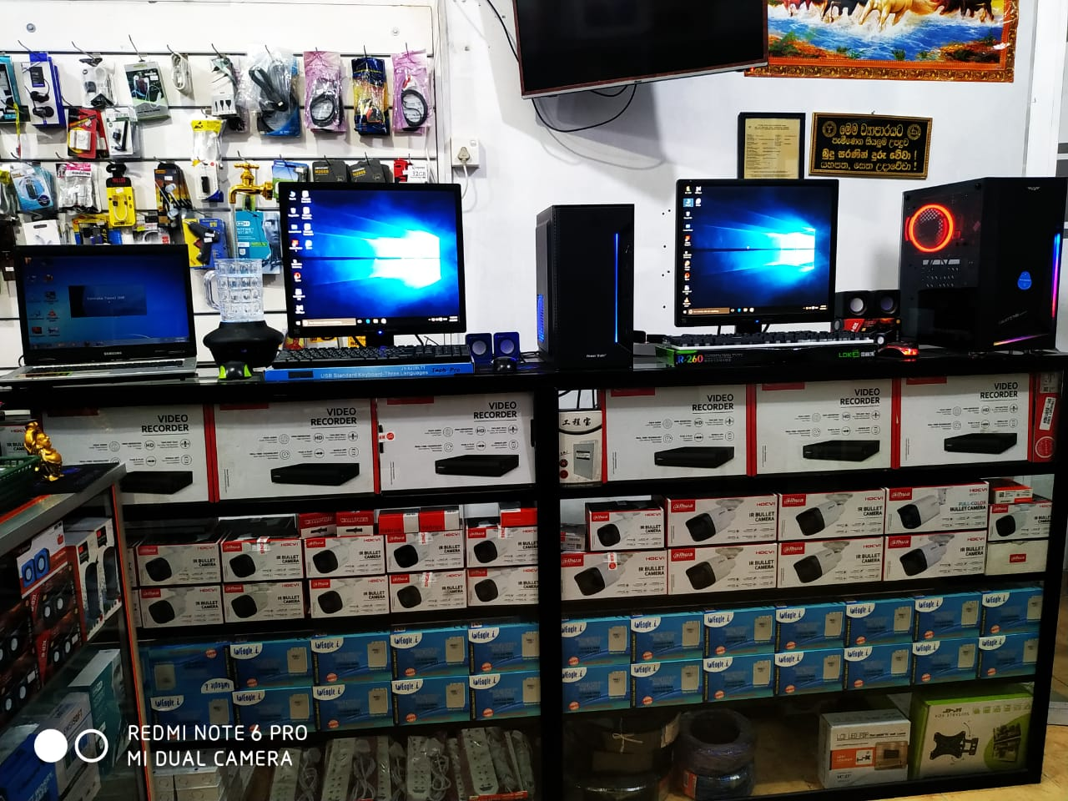

Figure 16 : Working Place 2.

Figure 17 : Customer Interaction.

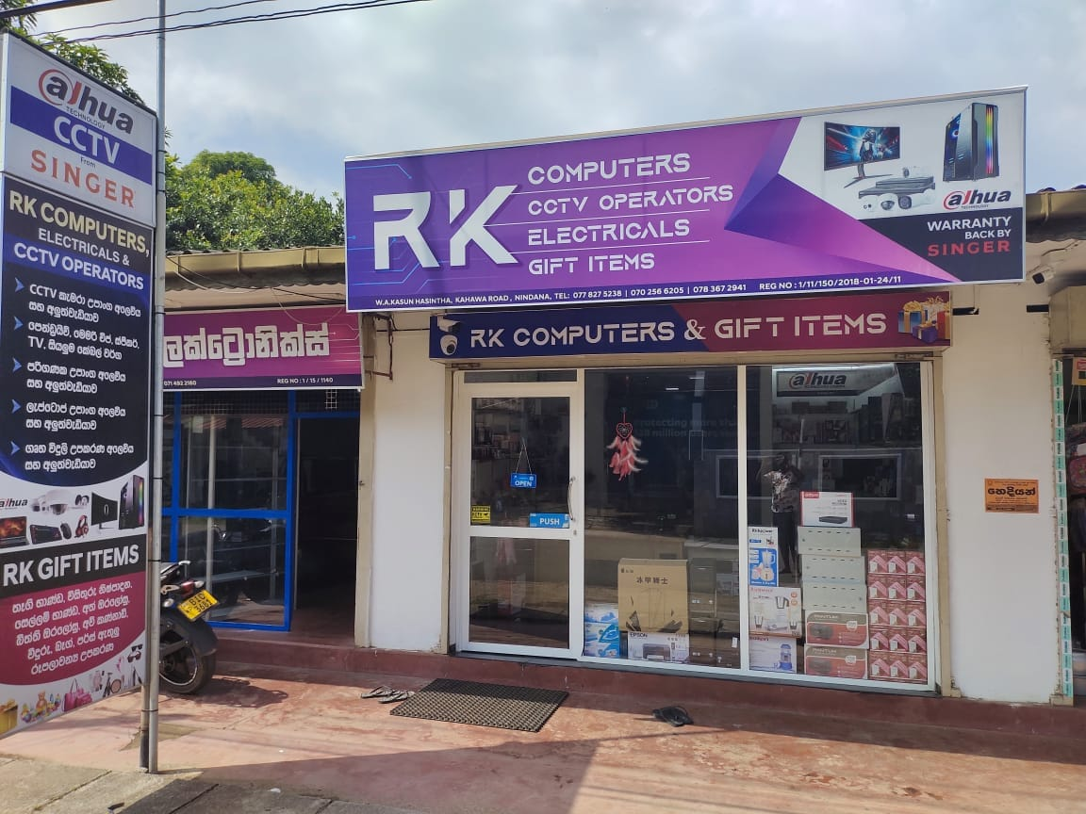

Figure 18: Ambalangoda Branch.

Figure 19: Ampara Branch.

## Appendix 3: Software Development Services Request Form

|  |  |
| --- | --- |
| SOFTWARE DEVELOPMENT SERVICES REQUEST FORM | |
| **REQUEST INFORMATION** | |
| NAME : W.A.Kasun Hasintha | |
| COMPANY : RK Computers and CCTV Operators  NAME | |
| ADDRESS : RK Computers and CCTV Operators,  Kahawa road, Nindana. | |
| **SERVICE REQUEST** | |
| New application | |
| Enhancement(s) to existing application. | |
| **Checkmark with solid fill** Replace an existing application. | |
| Automate a current manual process. | |
| Other | |
| **DETAILED DESCRIPTION OF THE REQUESTED SERVICES** | |
| Inventory Management System:  We are seeking a robust Inventory Management Software that will enable us to monitor stock levels, manage product variations, and automate reordering processes. Additionally, we request the integration of automated alerts to notify our staff when stock levels fall below predetermined thresholds, ensuring proactive inventory management.  Personalized Product Recommendations and Upselling:  We aim to implement personalized product recommendations based on customer purchase history and preferences. Your proficiency in developing algorithms that strategically promote relevant products will greatly contribute to enhancing customer satisfaction and driving increased sales through effective upselling.  Customer Support and FAQ Integration:  Efficient customer support is a priority for us. We are looking for integrated Customer Support functionalities within our chatbot to assist customers with common inquiries and issues promptly. Your experience in implementing responsive support mechanisms is crucial for ensuring a positive customer experience.  Point-of-Sale (POS) Integration:  Ensuring a smooth transaction experience is paramount. We request your assistance in integrating our systems with leading payment gateways and other POS systems to guarantee a secure, efficient, and user-friendly payment process for our customers. | |
| **WHAT BENEFITS WILL THIS SERVICES PROVIDE**. | |
| **Inventory Management System:**  Efficient Stock Monitoring: Real-time tracking of stock levels ensures optimal inventory management and prevents stockouts or overstock situations.  Automated Reordering: Streamlined reordering processes reduce manual workload, minimize errors, and ensure timely replenishment of stock.  Proactive Alerts: Automated alerts provide timely notifications, allowing staff to take proactive measures in response to low stock levels, preventing disruptions in supply chain management.  **Personalized Product Recommendations and Upselling:**  Improved Customer Experience: Personalized recommendations based on customer preferences enhance the overall shopping experience, leading to higher customer satisfaction.  Increased Sales: Effective upselling strategies driven by customer purchase history can result in higher average transaction values and increased revenue.  **Customer Support and FAQ Integration:**  Enhanced Customer Satisfaction: Quick and efficient customer support through integrated functionalities improves customer satisfaction and loyalty.  Time and Cost Savings: Automated responses to common inquiries reduce the workload on customer support staff, saving time and operational costs.  **Point-of-Sale (POS) Integration:**  Seamless Transactions: Integration with payment gateways ensures smooth and secure transactions, reducing friction in the buying process.  Improved Operational Efficiency: Automation of payment processes enhances operational efficiency, allowing staff to focus on other critical aspects of customer service. | |
| **AUTHORIZATION** | |
| SIGNATURE: | DATE:  2024/02/03 |

## Appendix 4: Current system user interface

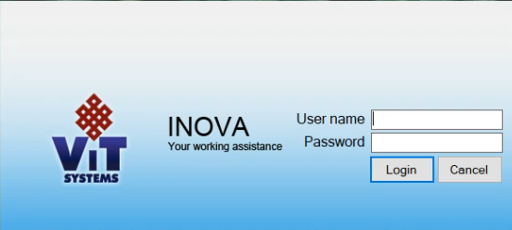

Figure 20: Logging Page UI.



Figure 21: Starting Page UI.